  - Wellington

The Wellington Caves were the first Australian caves to be formally described. They were visited by a party under the command of Captain Charles Sturt in 1828, and first described in a letter by Hamilton Hume, a member of the expedition. A more formal description later appeared in Sturt's report of his expedition, published in 1833.

Sir Thomas Mitchell, who succeeded Oxley as Surveyor-General, then visited the caves in 1830. He recognised that there were fossil bones in the caves and collected specimens that he sent to Great Britain for examination. In due course, Richard Owen, who described the extinct marsupial Diprotodon and others, described these. (Lane & Richards 1963)

Most cards appear to come from unidentified series, and we have simply numbered each of these.

Series 1
F Photograph with wide margins or frame; locale identified only by rubber stamp name on back.
1.1 (The Great Column, Cathedral Cave, Wellington) H in oval frame
A group of visitors, many carrying candles
1.2 Wellington Caves (depicts large chamber in Cathedral
cave with graffiti on rocks at L.H. side) H in oval frame
1.3 Wellington N S W (shows cave decoration shielded by
netting ) V with rectangular margins.

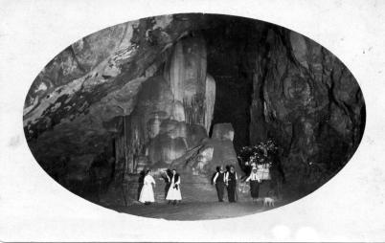
Series 2
F Real photograph without margins; title in superimposed Italic Caps.
2.1 The Pixie's Dell/ Wellington Caves, N.S.W. V K-D
2.2 The Frozen Waterfall/Gaden Cave, Wellington, N.S.W. V K-D
2.3 The Cathedral/ Wellington Caves, N.S.W. K-D

Series 3
F Real photograph with medium margins; title in Roman caps. in rectangular tablet.
3.1 Shawl Cave V (actually a scene in Cathedral Cave)
3.2 Gaden Cave H
3.3 Gaden Cave H (another view)

Series 4

F Real photograph with double marginal framing ; title is
rubber-stamped on white part of frame.
  - Wellington Caves H

5. Fellows Series

Pu G. Fellows, Arthur St., Wellington
F Real photo without margins
5.1 (Cathedral Cave) with party of male visitors again with candles and one person (guide?) with a magnesium ribbon lamp. H

6. Crown Studios

Pu Crown Studios, Sydney
F Real photo with medium margins; number, title and imprint at bottom
6.119 Altar Cave, Wellington V (Cathedral Cave)

7. Murray Views

Pu Murray Views, Gympie
F Normal Murray format. Either B&W (A) or Colour (B)
7A.19 Wellington Caves, Wellington., N.S.W
7A.20 Wellington Caves, Wellington., N.S.W.
7A.23 Coral Wall, Wellington Caves, N.S.W. H
7B.19 Wellington Caves, Wellington., N.S.W

